**Baseline: For credit level**

* Effective contribution to Knowledge Island Project
  + **Claim**: Yes, I have effectively contributed to the Knowledge Island project.
  + **Overview**: This has been a great learning experience and I am so grateful for having such a fantastic team which always wanted to work together.
  + **Evidence**:

|  |  |  |
| --- | --- | --- |
| ../../Dropbox/Screenshots/chat1.png | ../../Dropbox/Screenshots/chat2.png | ../../Dropbox/Screenshots/c9_chat.png |
| ../../Dropbox/Screenshots/c9_chat2.png |

* Effective contribution to Mandelbrot
  + **Claim**: Yes, I have effectively contributed to the Mandelbrot task
  + **Overview**: This was the coolest project during my time at HS1917, I definitely enjoyed the planning, implementation and aftermath. My partner was unable to help me, so I ended up doing it on my own. Still won the Mandelvision competition.
  + **Evidence**:

|  |  |  |
| --- | --- | --- |
| ../../Dropbox/Screenshots/mandelvision.png | ../../Dropbox/Screenshots/mandelvision2.png | |
| ../../Dropbox/Screenshots/gitMandel.png | |
|  | |

* Effective contribution to lab pair work and to the lab partners
  + **Claim**: Yes I have effectively contributed to the lab work and to my lab partners.
  + **Overview**: All my partners have been proactive and interpersonal programmers, it’s been an absolute pleasure.
  + **Evidence**:

|  |  |
| --- | --- |
| ../../Documents/MainDrive/Programming/C/HS1917/misc/time_management/gittyHub.png | ../../Documents/MainDrive/Programming/C/HS1917/misc/time_management/mod_6_imgs/parsing.png |
| ../../Documents/MainDrive/Programming/C/HS1917/misc/time_management/mod_6_imgs/reverse.png | |

* Assisted others in the course
  + **Claim**: Yes I have assisted others in this course.
  + **Overview**: It has been my pleasure to not only help people in front of me in the labs, but also leave my thoughts on openlearning.com
  + **Evidence**:

|  |  |
| --- | --- |
| ../../Dropbox/Screenshots/helpout1.png | ../../Dropbox/Screenshots/helpout2.png |
|  | |

**Additional factors, look for:**

* Evidence of planning and reflection on teamwork
  + **Claim**: Yes I have planned and reflected on my teamwork abilities.
  + **Overview**: My new experiences with teamwork have allowed me to reflect on things which weren’t so obvious to before.
  + **Evidence**:

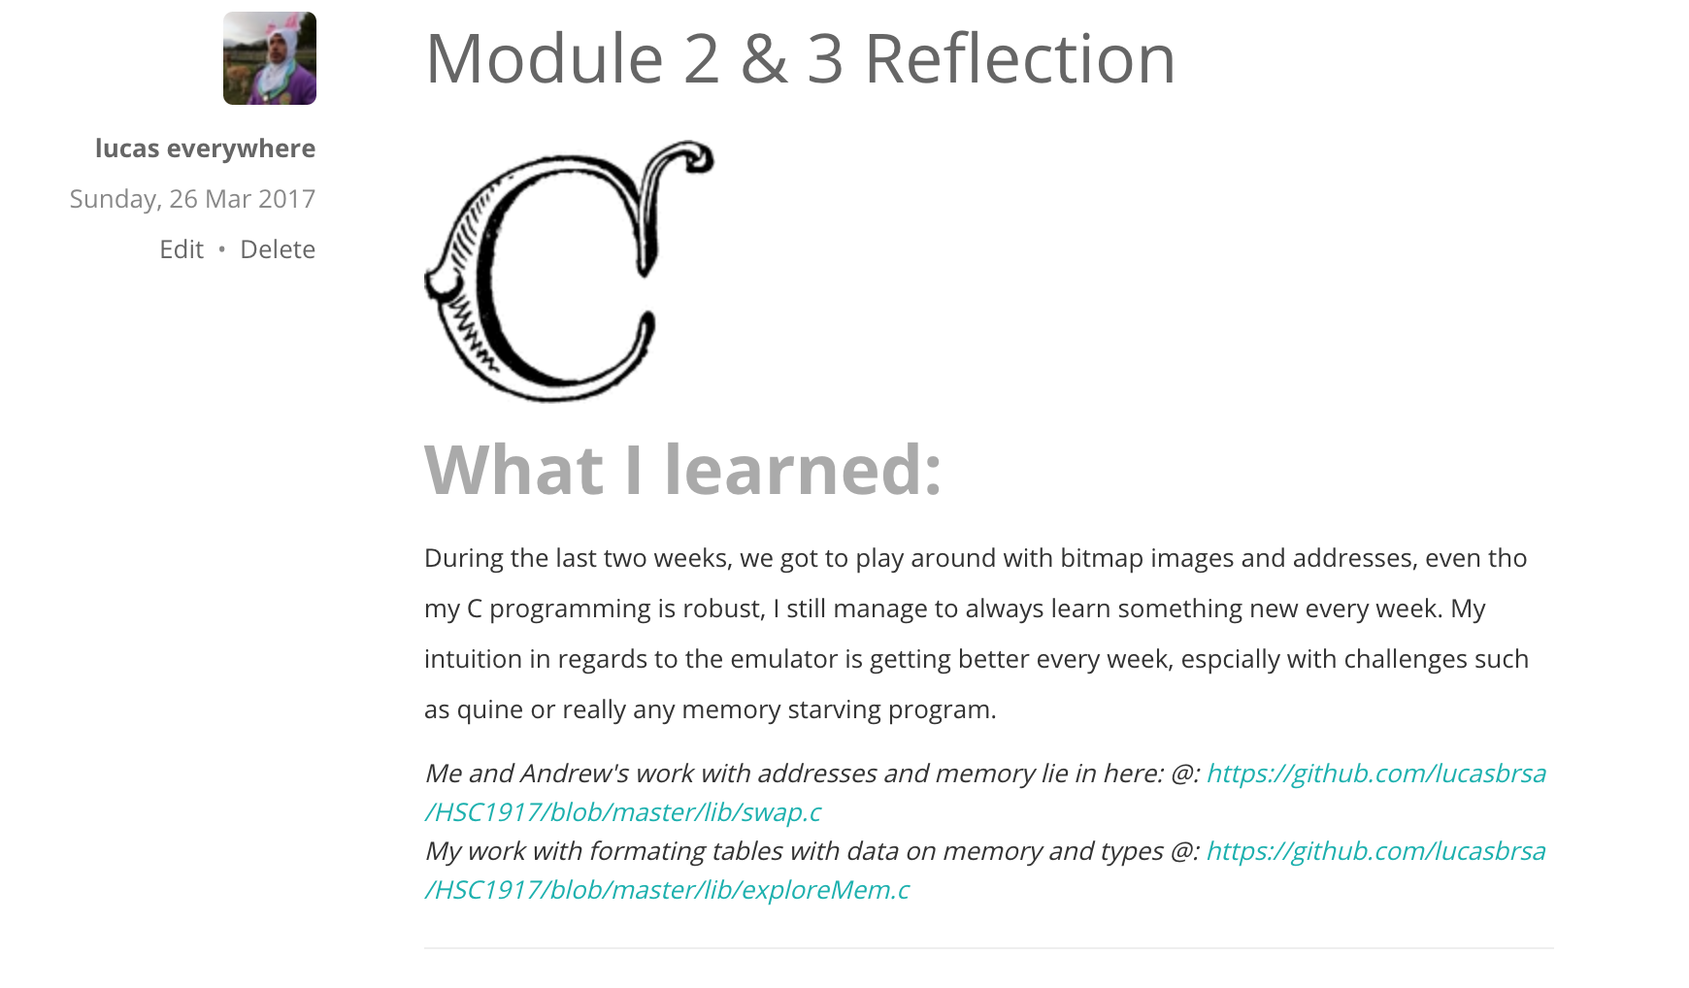

* Evidence of carrying out planning
  + **Claim**: Yes I have carried out my planning.
  + **Overview**: The great practice of planning has allowed me to plan many things ahead, especially my week.
  + **Evidence**:

|  |
| --- |
| ../../Documents/MainDrive/Programming/C/HS1917/misc/time_manage/timetable.png |
|  |

* Evidence of acting on reflection
  + **Claim**: I have acted upon my reflection.
  + **Overview**: Acting upon my reflection involved making blog posts.
  + **Evidence**:

|  |  |
| --- | --- |
| ../../Documents/MainDrive/Programming/C/HS1917/misc/time_manage/blog/blog_1.png | ../../Documents/MainDrive/Programming/C/HS1917/misc/time_manage/blog/blog_2.png |
| ../../Documents/MainDrive/Programming/C/HS1917/misc/time_manage/blog/blog_3.png | ../../Documents/MainDrive/Programming/C/HS1917/misc/time_manage/blog/blog_4.png |
| ../../Documents/MainDrive/Programming/C/HS1917/misc/time_manage/blog/blog_5.png | ../../Documents/MainDrive/Programming/C/HS1917/misc/time_manage/blog/blog_6.png |
|  | ../../Documents/MainDrive/Programming/C/HS1917/misc/time_manage/blog/blog_8.png |

* Evidence of improvement (More impressive if evidence is sustained rather than mainly all the end)
  + **Claim**: I have improved during HS1917
  + **Overview**: There is always room for improvement, this is so true especially in HS1917.
  + **Evidence**:

**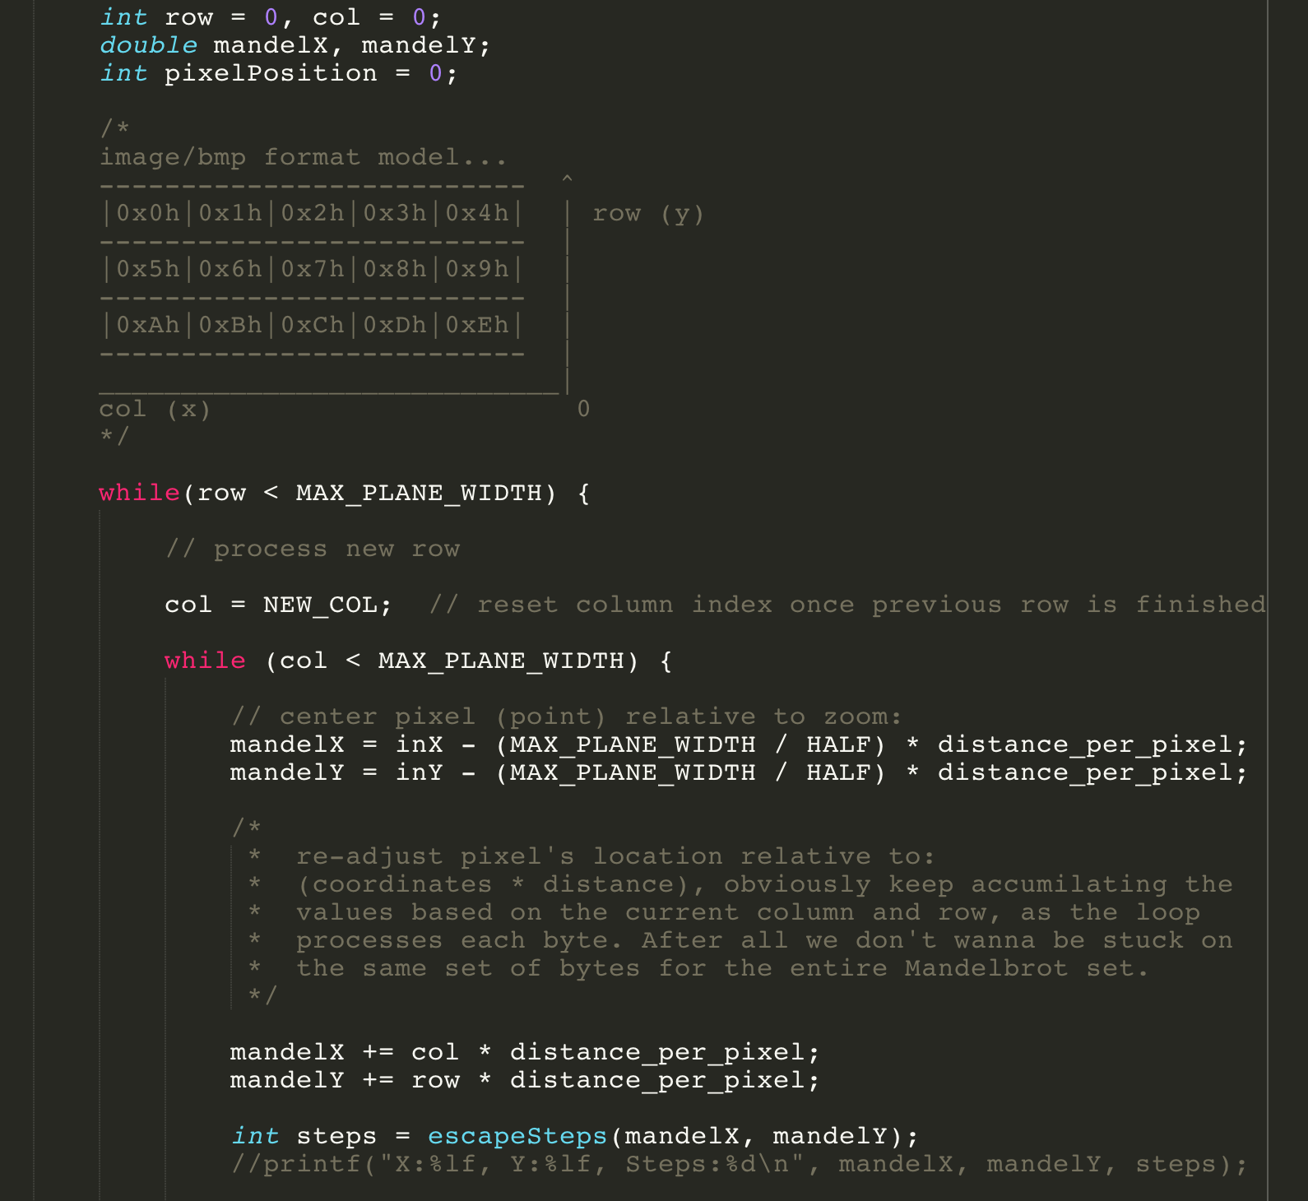**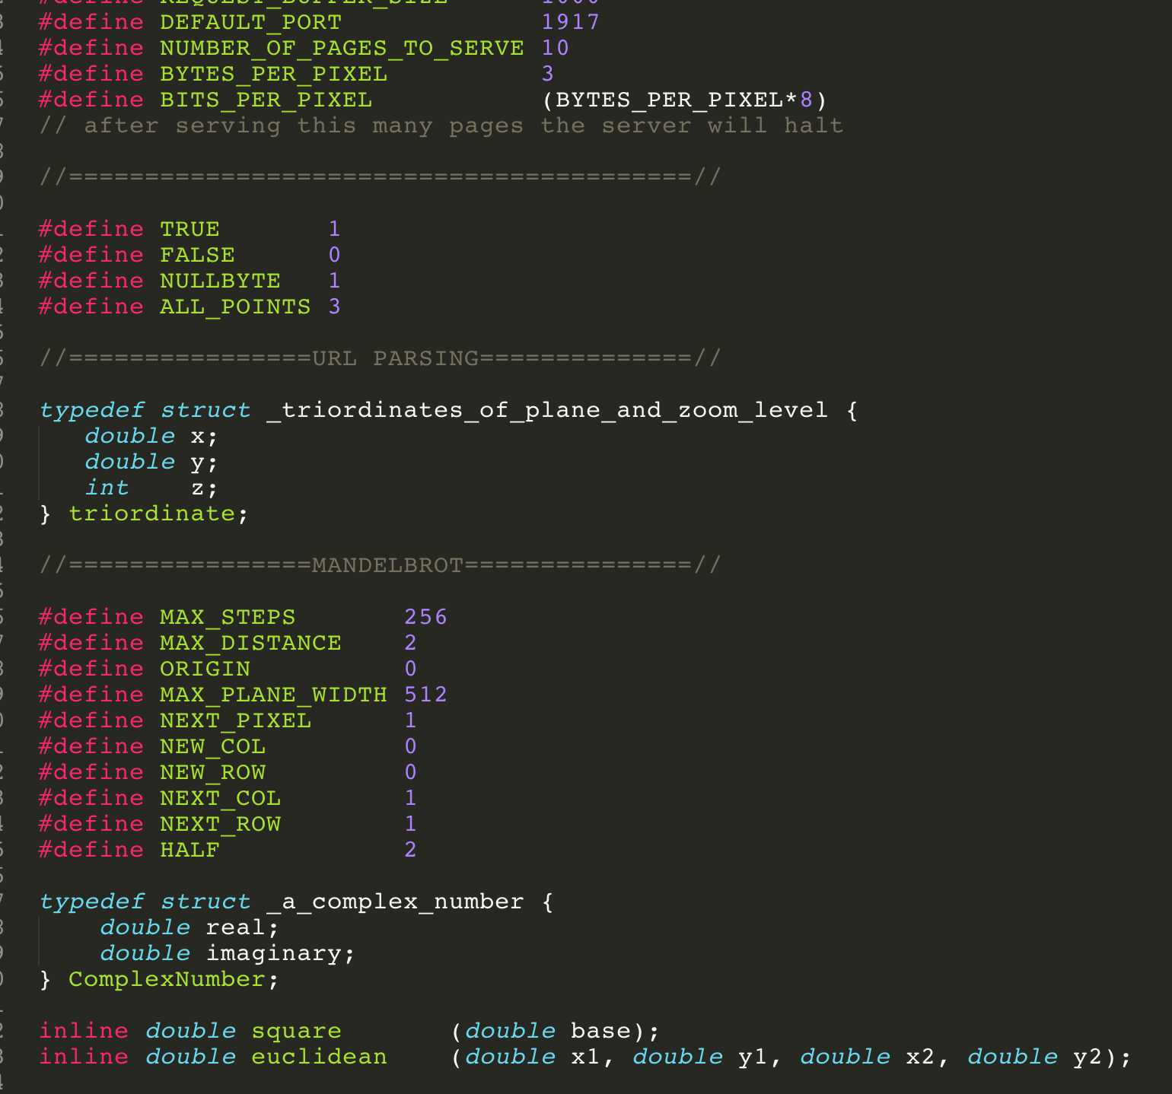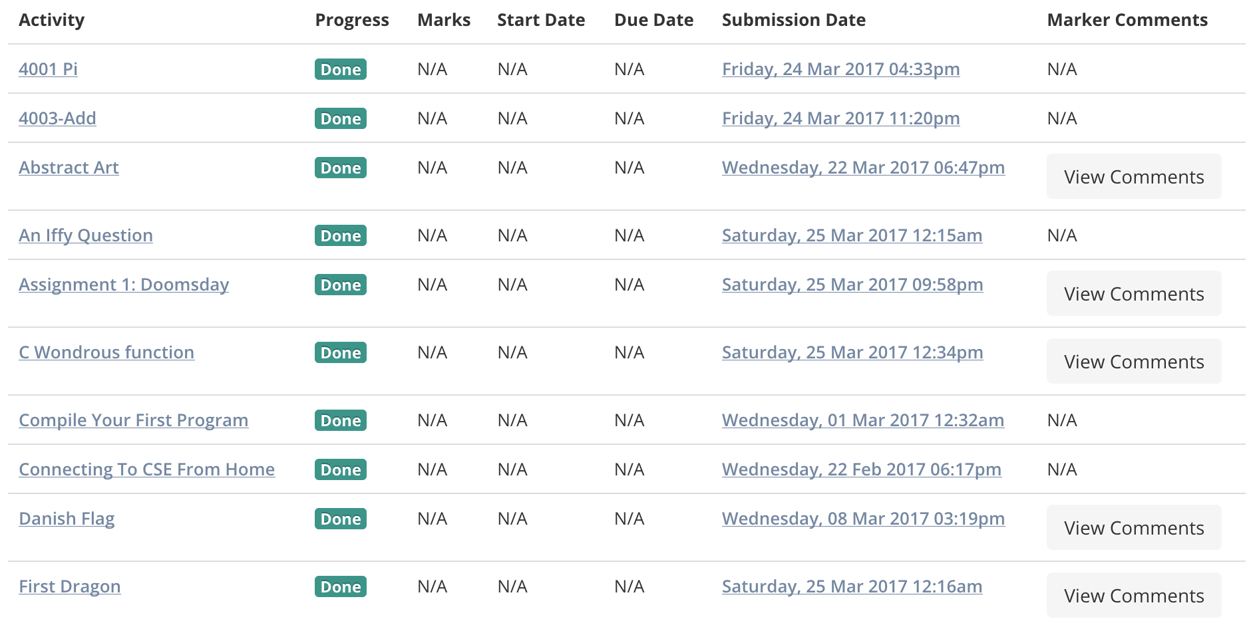

* Identifying problems and working out strategies to fix them (more impressive if problems identified *before* the last minute)
  + **Claim**: Yes I have unidentified problems and implemented strategies to fix them.
  + **Overview**: This has been a big part of this course. First step to fixing a problem is realising there is one, then the implementation of a strategy to solve it, much like our AI.
  + **Evidence**:

**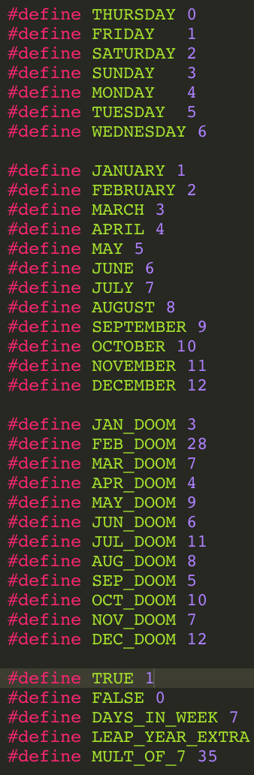**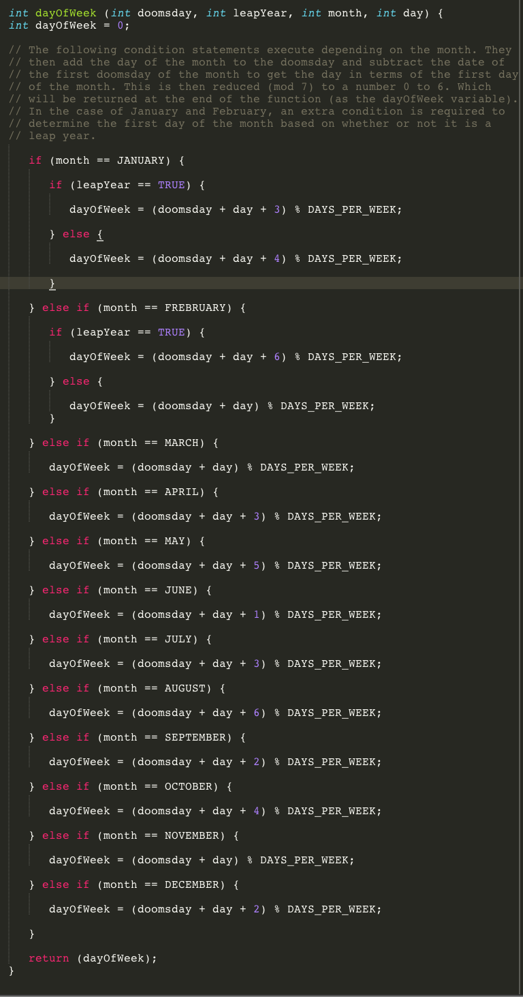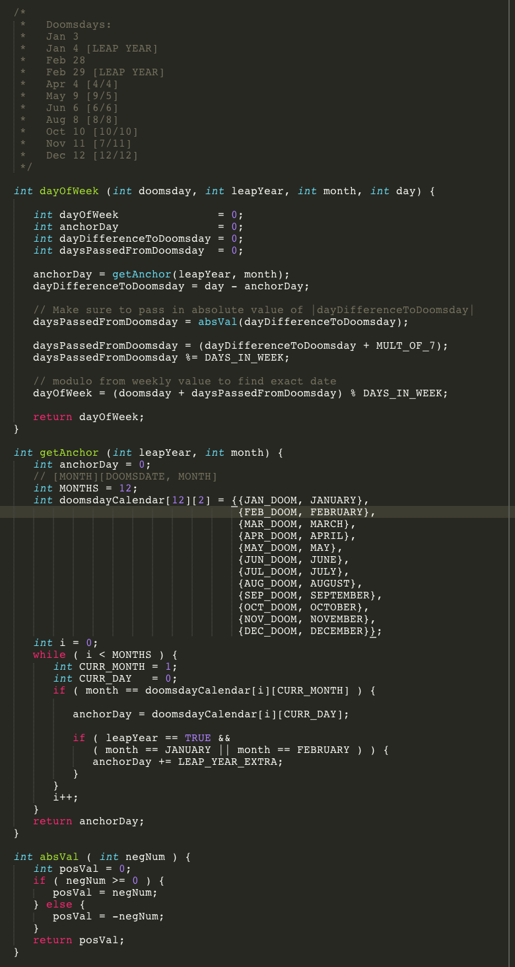

**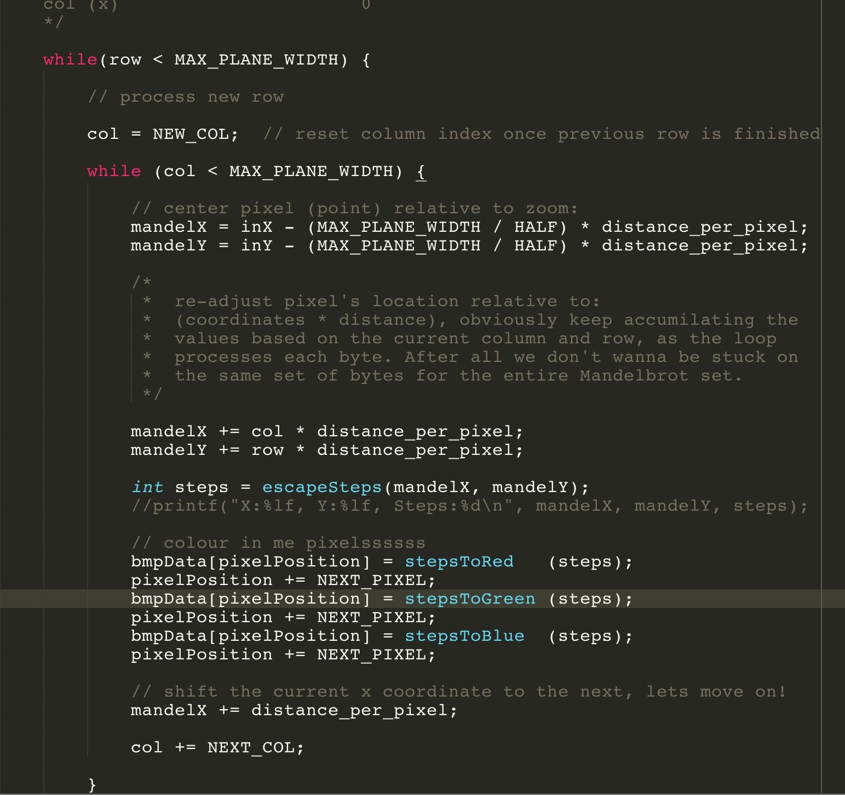**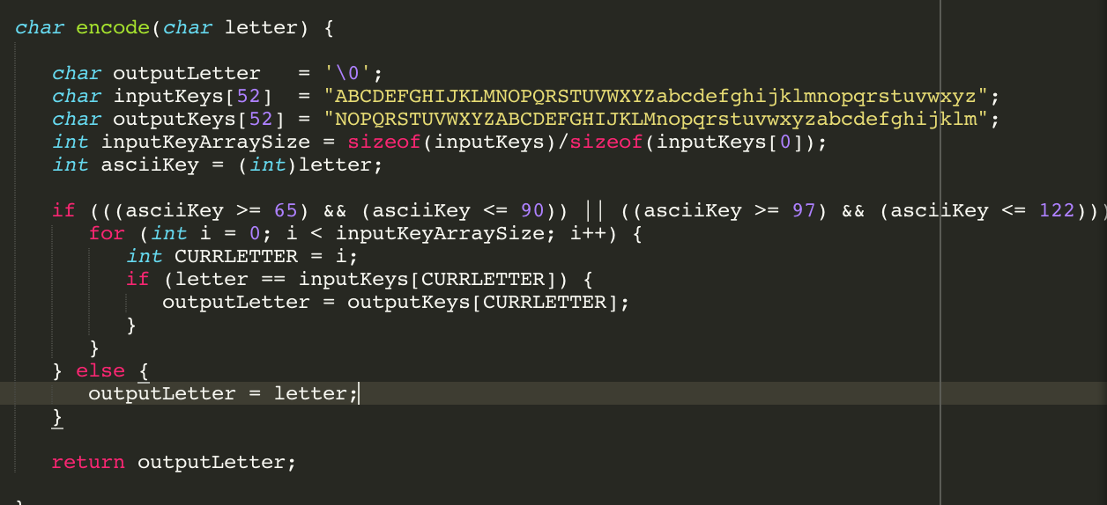

* Evidence of leadership
  + **Claim**: I have maintained sustained leadership throughout HS1917.
  + **Overview**: I made it a personal goal to improve my leadership skills and ultimately achieve direction.
  + **Evidence**:

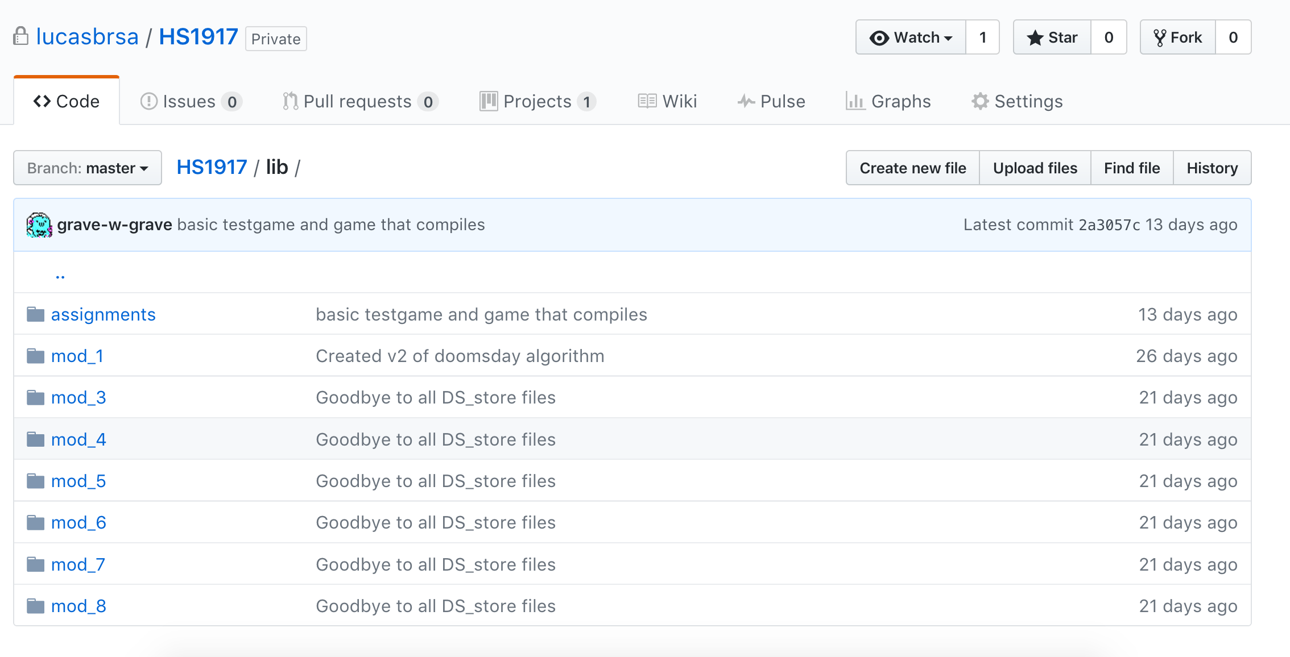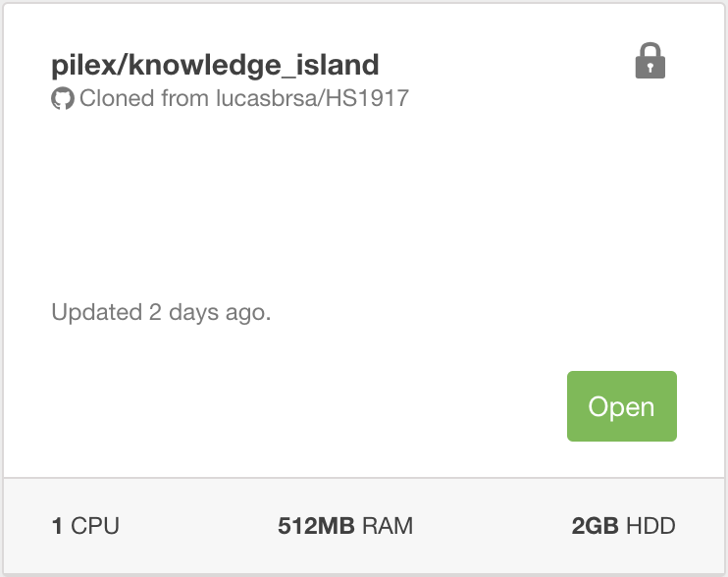

* Evidence of change
  + **Claim**: Yes, I have changed during this course.
  + **Overview**: From coming late to the tuts and going to the wrong tuts to helping and getting to know friendly people in my tut.
  + **Evidence**:

**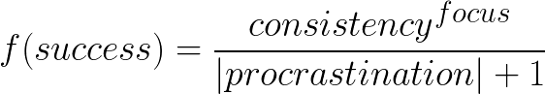**

* Evidence of understanding what is effective teamwork
  + **Claim**: I understand what effective teamwork really is.
  + **Overview**: Effective teamwork has been the core focus during both the Mega tuts and the local tuts. It drove my team to complete the project and excel in the linked-list prac exams.
  + **Evidence**:

**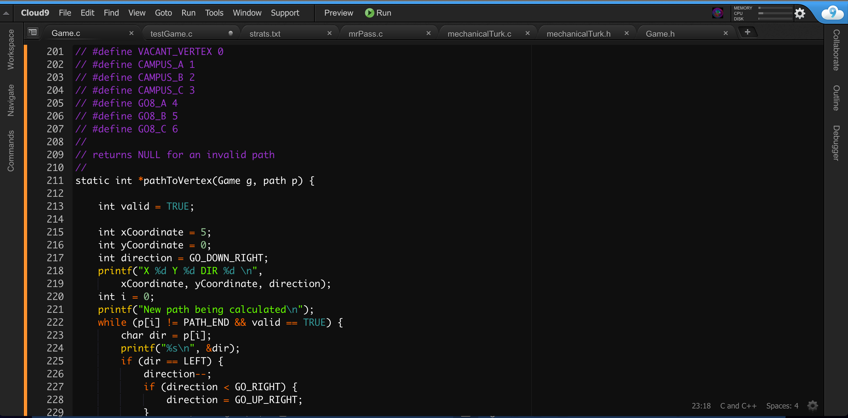**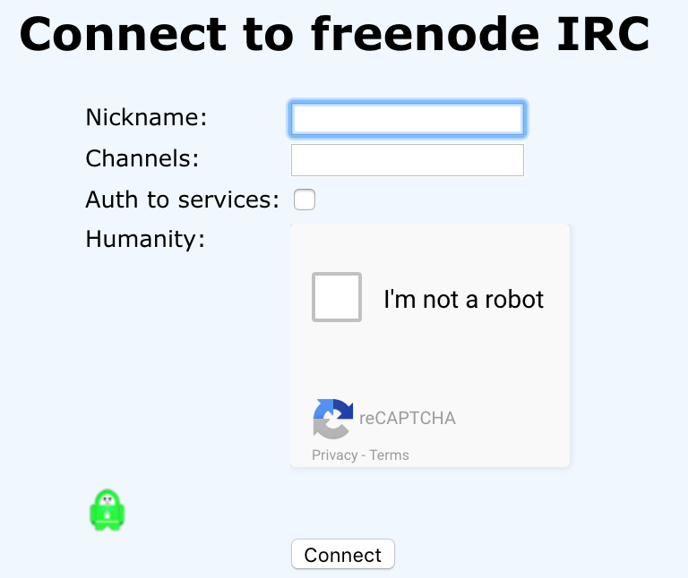

* Evidence of supporting and/or encouraging others
  + **Claim**: I have supported and encourage others throughout the course.
  + **Overview**: I can’t show evidence for verbal encouragement, however I did leave my thoughts on peoples blogs.
  + **Evidence**:

